Bill of Materials / Bill of Substance
Client: Nohro Aps
Product Name: Product Code:
Supplier Code: Date: _______

http://www.commonchemistry.org/ Please use this website to look up the
relevant CAS number for your products.

 | Bill of Materials |  |  |  |  | Bill of Substances
Product picture | Component | Breakdown of Component | Raw Materials / Ingredients | Country Of Origin | % in Final Product (must total 100%) | Material / substance weight in final product (g) | Function of Material in production | Concentration in  % | CAS number (where relevant) (website listed below) | Testing Required - List relevant chemical tests | Material Test Certificates - number and date | Chemical Saftey Assessment (CSA) EU banned or restricted substances (REACH compliance) | Comments

EXAMPLE ON HOW TO FILL
 | FACEPAINT AND HAIRCOLOR SET
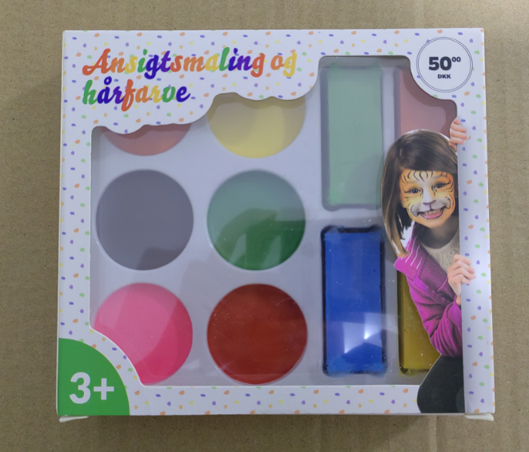 | Facepaint | FACEPAINT | CERESINE WAX,WHITE OZOKERITE,26 MINERAL OIL,MICA FLOUR,ALLURA RED,GRASAL YELLOW,ACID RED 92,DISPERSE BLUE1,ACETYLENE CARBON BLACK | China | 18% | 19,6 g | Facepaint | 100% | xxx | CPSA  EN71-1,2,3
 | Haircolour | HAIRCOLOR | CERESINE WAX,WHITE OZOKERITE,26 MINERAL OIL,MICA FLOUR,ALLURA RED/GRASAL YELLOW,DISPERSE BLUE 1,GRASAL YELLOW | China | 73% | 80g | Haircolor | 100% | xxx | CPSA  EN71-1,2,3
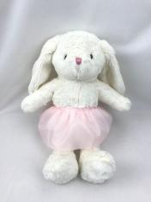 | DK-202017901 | Rabbit shell fabric -Off-white geim velvet | 100% Polyester | China | 23.98% | 60g
 | Rabbit -2010270 | Rabbit ear Off-white geim velvet | 100% Polyester | China | 8% | 20g
 |  | Rabbit Thread | 100% Polyester | China | 0.4% | 1g
 |  | Rabbit skirt -pink net | 100% Polyester | China | 0.8% | 2g
 |  | Pink skirt-pink silks and satins | 100% Polyester | China | 1.11% | 3g
 |  | Pink grosgrain ribbon | 100% Polyester | China | 1.11% | 3g
 |  | Rabbit eyes-white Thread | 100% Polyester | China | 0.04% | 0.1g
 |  | Rabbit eyes-black Thread | 100% Polyester | China | 0.08% | 0.2g
 |  | Rabbit nose-pink Thread | 100% Cotton | China | 0.08% | 0.2g
 |  | Stuffing-PP cotton | 100% Polyester | China | 64.4% | 162g
http://www.commonchemistry.org/ Please use this website to look up the
relevant CAS number for your products.

Bill of Materials / Bill of Substance (For a definition of each column, move the cursor over the coloured column heading)
Client:
Product Name: |  | Product Code:
Supplier Code: |  | Date:

Bill of Materials |  |  |  |  | Bill of Substances
Component | Breakdown of Component | Raw Materials / Ingredients | Country Of Origin | % in Final Product (must total 100%) | Material / substance weight in final product (g) | Function of Material in production | Concentration in  % | CAS number (where relevant) | Testing Required - List relevant chemical tests | Test Certificates - number and date | Chemical Saftey Assessment (CSA) EU banned or restricted substances (REACH compliance) | Comments
EXAMPLE: Height Chart
1.Board | pure kraft | cellulose 88.00%  starch 4.00%  H2O 8.00% | China | 68 | 60 | substrate | 100 | 9004-34-6  9005-25-8  7732-18-5 |  |  | Not on REACH list at date of BOS completion
 |  |  |  |  |  |  |  | 5281-04-9
 |  |  |  |  |  |  |  | 25053-15-0
 | Ink | Blue YT UV Ink (UV HY-BD) process UV Ink | China | 2 | 0 | dye | 0,2 | 71868-10-5  9002-88-4  28961-43-5  42978-66-5 |  |  | Not on REACH list at date of BOS completion | Substance identified for REACH evaluation in 2014
 |  |  |  |  |  |  |  |  | '-15 Phthalates  '-16CFR 1303 Ban of the Lead-Containing Paint and Total lead content less than 40ppm  '-ASTM F963-08 FULL TEST '-CPSIA 2008  '-EN71 Part 3  '-ISO 8124  '-Total Cadmium Content | HSTR12100055CB, Oct 26,2012
 |  |  |  |  |  |  |  | 7732-18-5 |  | HSTR12100055CB, Oct 26,2012
 |  |  |  |  |  |  |  | 9003-49-0 |  | HSTR12100055CB, Oct 26,2012
 |  |  |  |  |  |  |  | 8050-15-5 |  | HSTR12100055CB, Oct 26,2012
 |  | water 45.00-55.00% |  |  |  |  |  | 119345-04-9 |  | HSTR12100055CB, Oct 26,2012
 |  | Poly(butyl acrylate) 15.00-25.00%  Hercolyn D 0.10-1.00% |  |  |  |  |  | 9003-53-6 |  | HSTR12100055CB, Oct 26,2012  HSTR12100055CB, Oct 26,2012
 | Glue | SODIUM DODECYL DIPHENYL ETHER  DISULFONATE 0.10-1.00%  poly(styrene) 10.00-30.00% | China | 2 | 0 | adhesive | 0,2 |  |  |  | Identified as an existing active substance but not notified. | Full REACH registration required for imports over 1 tonne.
2.String | polyester | 100% polyester | China | 3 | 0,01
3. Pen | barrel | brass 80% | Taiwan | 15 | 0,04 | substrate | 0,8
 | refill | silicone 12% | Taiwan | 3 | 0 | substrate | 1
 | clip | iron 8% | China | 5 | 0 |  | 0,3
 | ink | Rosin modified phenolic resin 25.00-35.00%  Refined linseed oil 20.00-30.00% Petroleum Hydrocarbon 15.00-25.00%  Pigments Black 15.00-25.00%  wax 3.00-5.00% | China | 2 | 0 |  | 0,2 | 70248-46-3  8001-26-1  8042- 47-5  1333-86-4  9002-88-4 |  |  | Not on REACH list at date of BOS completion

